NMSBVI Summer Programs – 2018
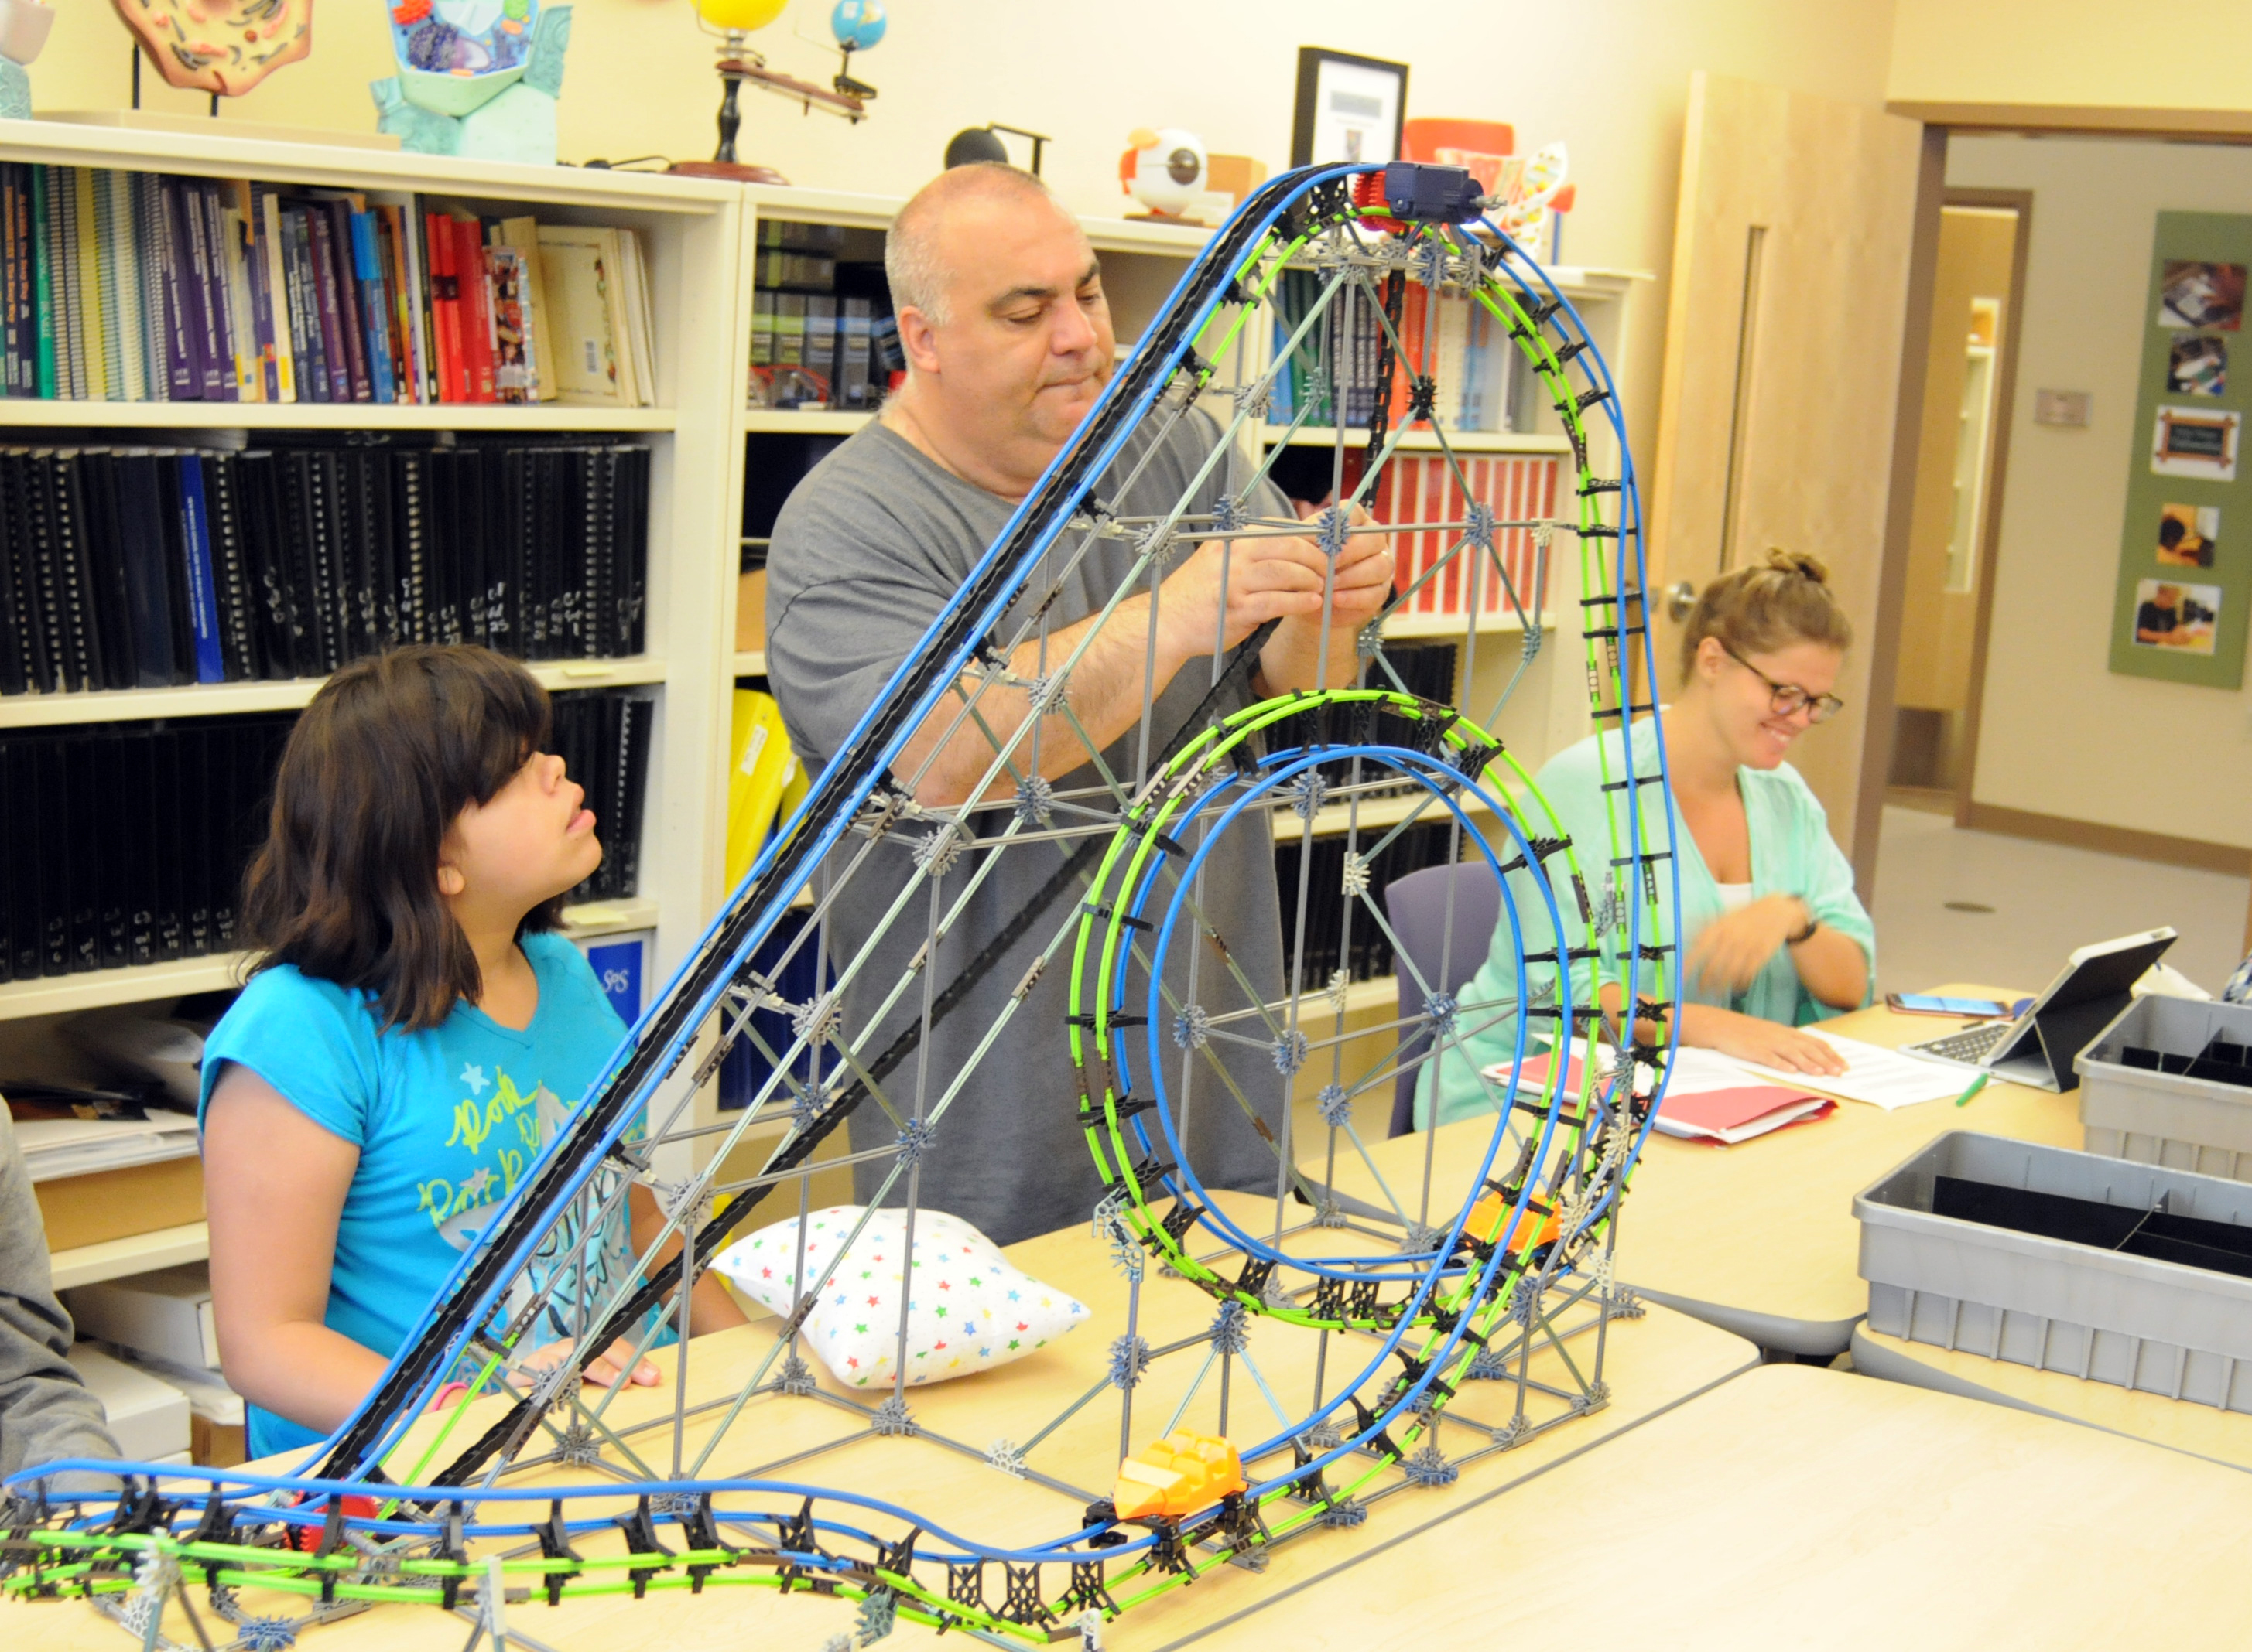Who?
The New Mexico School for the Blind and Visually Impaired (NMSBVI) will again be running a series of summer camps around the state for academic students with visual impairments. Eligible students will have a diagnosed (educational) visual impairment, be enrolled in a participating New Mexico school district during the 2017-18 school year, be a minimum of 6 years of age but not yet graduated, be capable of managing their behaviors while at the camp, and not require medications during the hours of the camp with the exception of the Alamogordo camp. (We will have a nurse during the day for the Alamogordo camp.)
What?
Over the past several summers, NMSBVI has run a series of four-day long camps in Gallup, Farmington, Santa Fe, Clovis, Las Cruces, Artesia, Carlsbad, Roswell, and Albuquerque. NMSBVI collaborated with local districts and Teachers of the Visually Impaired (TVIs) and Orientation & Mobility Specialists (O&Ms) to secure a site in the local community, identify students and address VI specific skills that can be challenging to teach during the school year. NMSBVI will again collaborate with local districts, TVIs and O&Ms this summer to help meet the needs of New Mexico students with visual impairments.
The schedule for this summer is:
May 26th – 30th: O&M trip for high school students with advanced O&M skills
Week of June 4th: Gallup
Week of June 11th: Santa Fe
Week of June 18th: Shiprock (possibly at Kirtland Elementary)
Week of June 25th: no camps
Week of July 2nd: Albuquerque
Week of July 9th: Artesia
Week of July 16th: Alamogordo
July 20th – 23rd: out of state fun trip to the beach (students must participate in one of the camps in order to be eligible to go on the out of state trip)
The day camps, regardless of where in the state they are, run Mondays-Thursdays. The camp in Alamogordo is residential with students arriving on 7/15 and staying the dorms through 7/19.

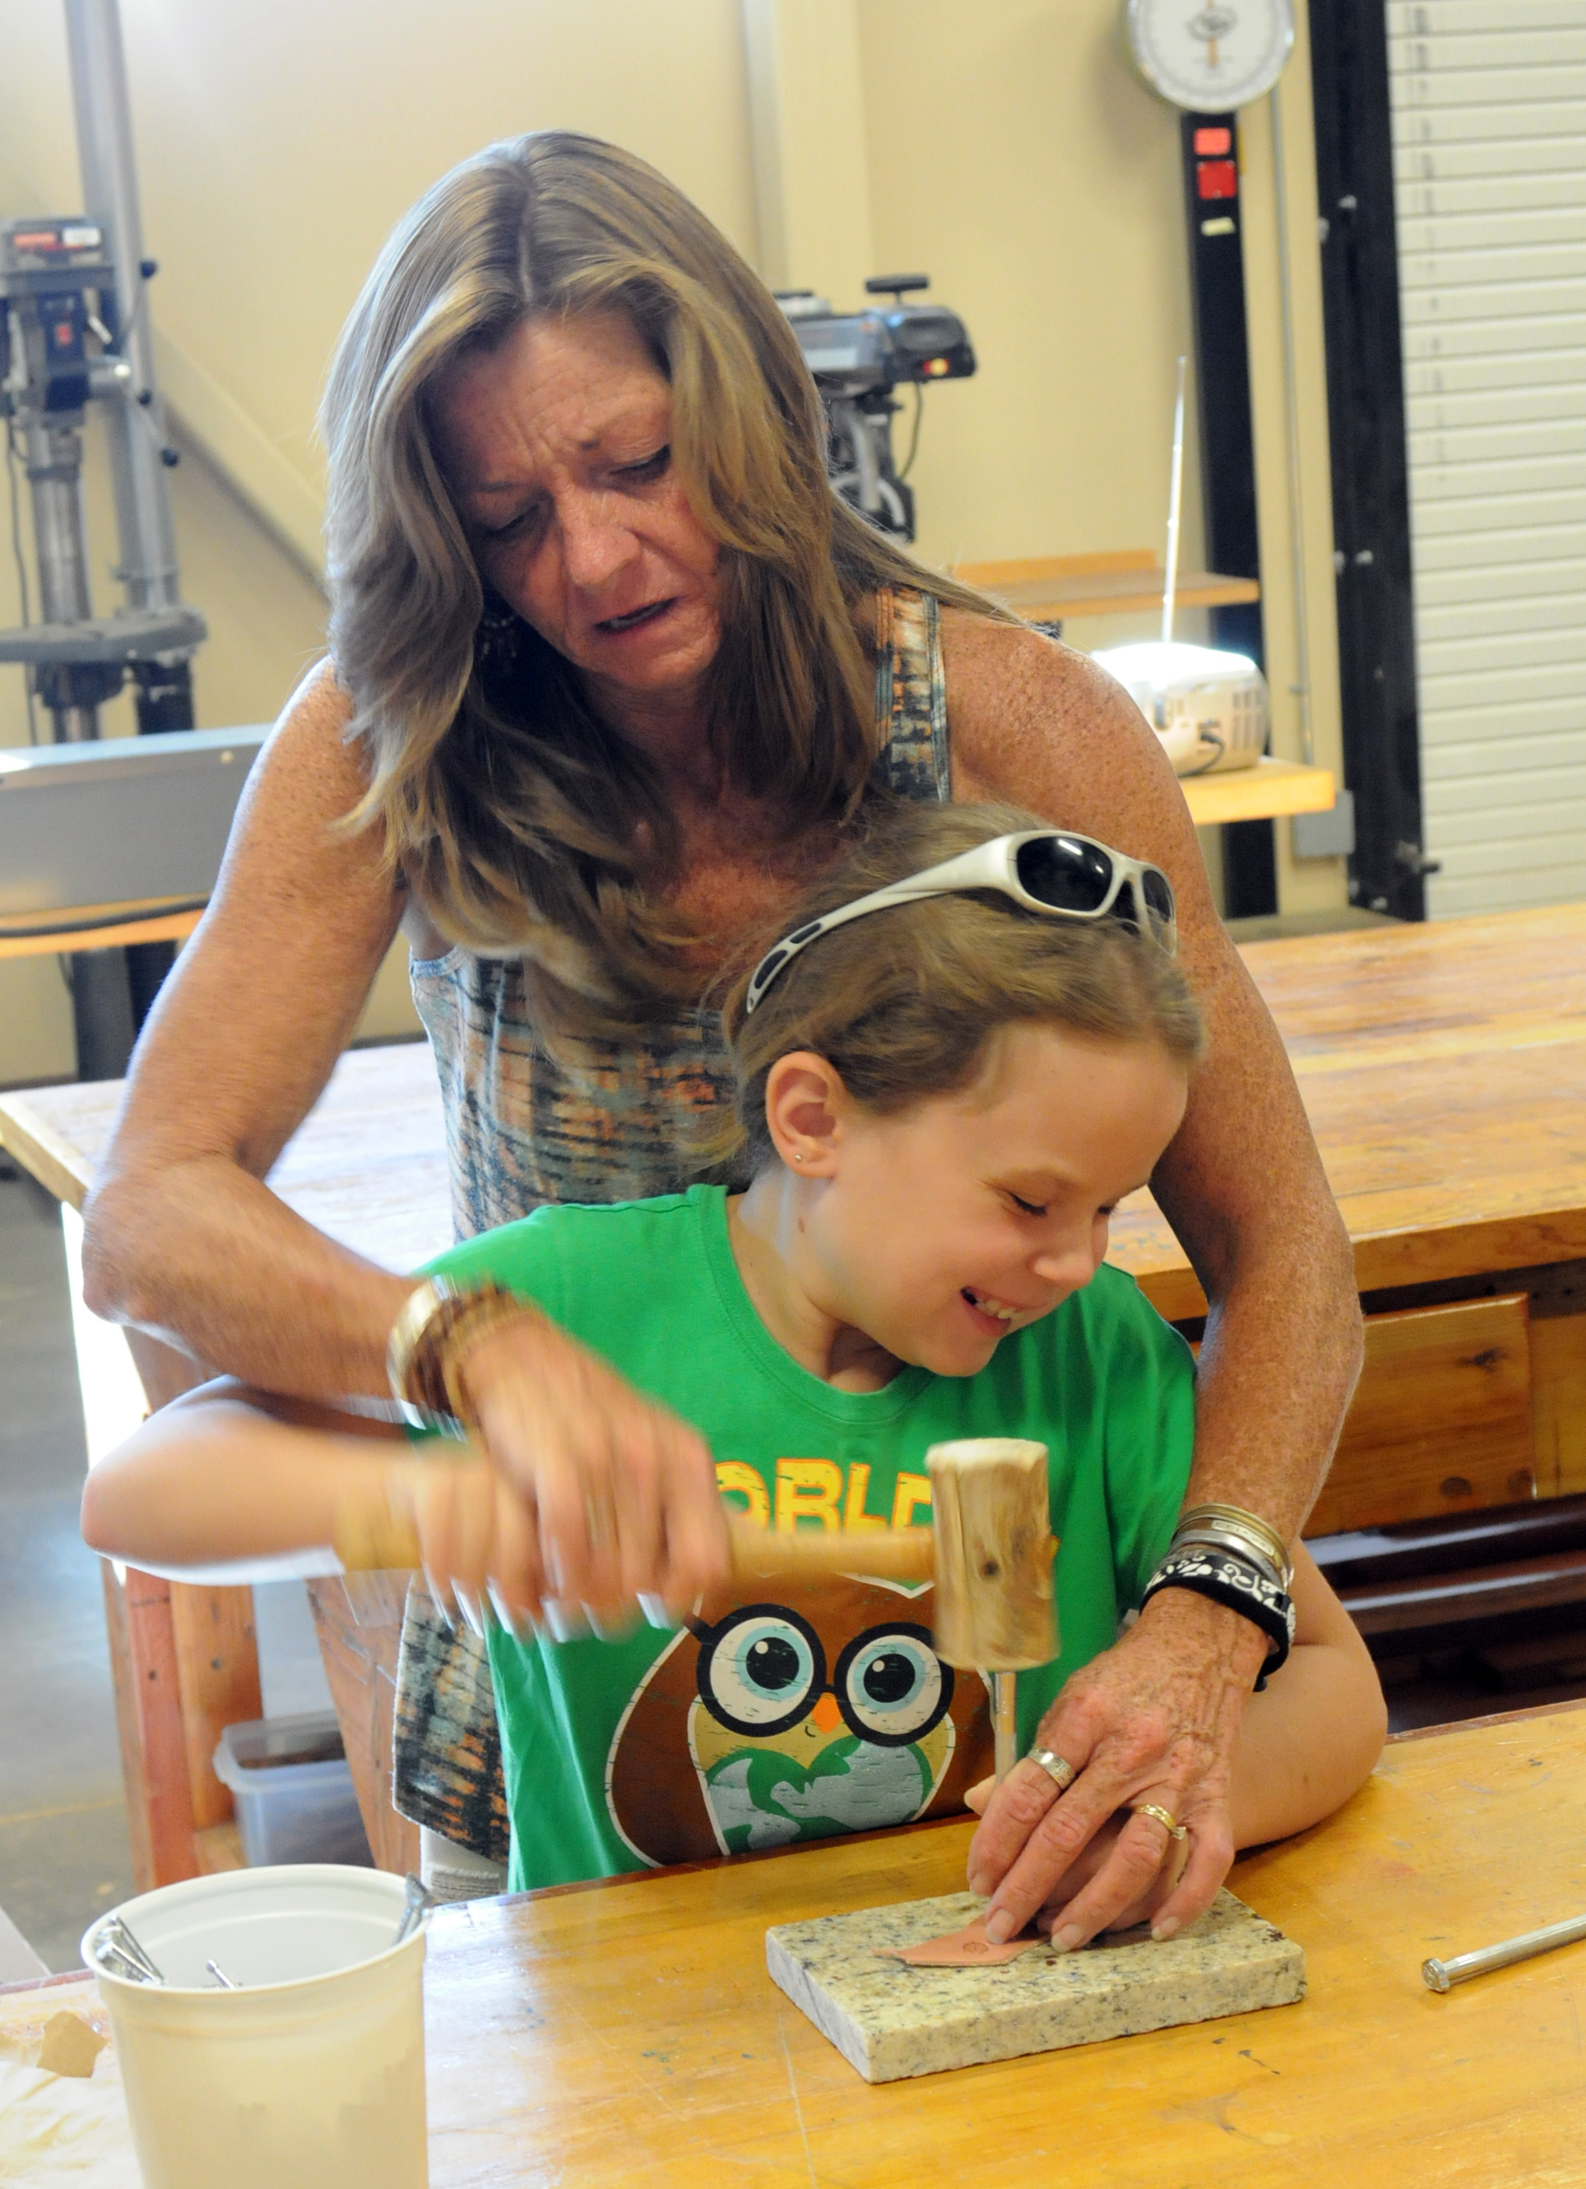Where?
Camps in local districts are typically run at one of the local school buildings. The Albuquerque camp will be held at the NMSBVI Preschool campus (801 Stephen Moody St SE) and NMSBVI may be able to help with daily transportation to/from the camp. A residential camp is being planned for Alamogordo, and we run transportation to/from Albuquerque for the Alamogordo camp. Most of the students who come to the Alamogordo camp choose to stay for the out of state trip.
Why?
Students with visual impairments need to master all of the standard core curriculum concepts as their peers but also have to master an extensive set of skills that comprise what is commonly referred to as the Expanded Core Curriculum (ECC). Many students with visual impairments require adaptations and VI specific skills to fully benefit from standard classes such as math and science. NMSBVI’s summer camps place an emphasis on math and science – two of the most difficult to modify academic classes – as well as VI specific technology, which enables students to better access all of the standard academic classes. NMSBVI also provides instruction in ECC areas such as Independent Living Skills (ILS), O&M, and braille. The camps supplement instruction that students with visual impairments receive from TVIs and O&Ms during the school year. Due to the competing demands, it can be difficult to fit all of the skills in during the school year. The NMSBVI summer camps can help.
As an added bonus:
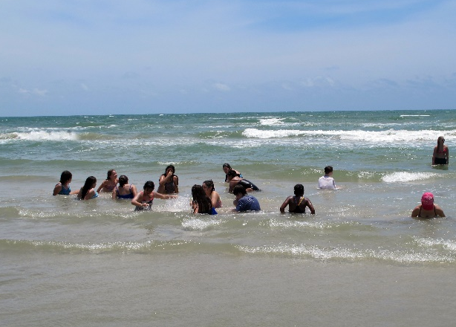
The out of state trip is in the planning stages but has typically included a day at the beach (Corpus Christi or San Diego) and another day long activity such as 6 Flags San Antonio or the San Diego Zoo. To be eligible for the trip, students must:
- Successfully participate in one of the camps that NMSBVI will hold around the state
- Have the maturity necessary to be away from home for four days
- Be able to manage their behaviors while away from home for four days
- Be cleared to attend by NMSBVI’s Health Services
For more information, please contact:
Ron Later, NMSBVI Summer Program Coordinator
rlater@nmsbvi.k12.nm.us
800-437-3505 extension 4478

